PAL and TEE Calculation

1. Define 24-Hour Periods for 7 Days
- Input: Segment.Start.Time (Column C in the CSV file).
- Process:
  - Start the first 24-hour period from the earliest Segment.Start.Time (e.g., 07:05:41).
  - End the period at the latest time on the next day that is earlier than the start time (e.g., 06:52:20).
  - Repeat this process for 7 consecutive days.

2. Calculate MET
- Input: Magnitude.mean current (Column O in the CSV file).
- Formula:
MET = (Magnitude.mean*(4800/125.34))^0.6983

3. Calculate BEE
- Inputs:
  - Gender (Male/Female)
  - Age (years)
  - Height (meters)
  - Weight (kg)
- Formulas:
  - For Men:
BEE= 293 − 3.8 × age (years) + 456.4 × height (meters) + 10.12 × weight (kg)
For Women:
BEE= 247 − 2.67 × age (years) + 401.5 × height (meters) + 8.6 × weight (kg)

4. Calculate Δ PAL
- Inputs:
  - METs (from Step 2)
  - Segment.Duration.prior (Column E in the CSV file) (they are in seconds and need to changed to the minutes)
  - BEE (from Step 3)
  - Weight (kg)
- Formula:
ΔPAL=(METs−1)×[(1.15/0.9)×Duration]/1440. / BEE/[(0.0175×1440×weight(kg) ]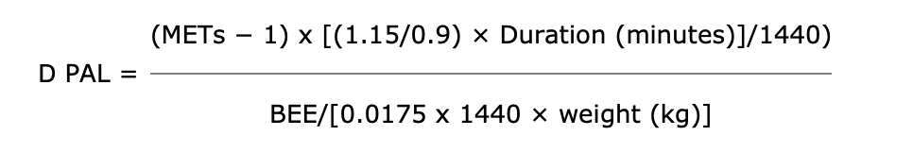

5. Calculate Daily PAL
- Input: Δ PAL values (from Step 4).
- Formula:
PAL=1.1+∑ΔPALi
Where ΔPALi represents the Δ PAL for each activity in the 24-hour period.

6. Determine PA (Physical Activity Category)
- Input: Daily PAL (from Step 5).
- Categories:
  - For Men:
    - Sedentary: PA = 1.0, when 1.0≤PAL<1.41.0≤PAL<1.4
    - Low Active: PA = 1.12, when 1.4≤PAL<1.61.4≤PAL<1.6
    - Active: PA = 1.27, when 1.6≤PAL<1.91.6≤PAL<1.9
    - Very Active: PA = 1.54, when 1.9≤PAL<2.51.9≤PAL<2.5
  - For Women:
    - Sedentary: PA = 1.0, when 1.0≤PAL<1.41.0≤PAL<1.4
    - Low Active: PA = 1.14, when 1.4≤PAL<1.61.4≤PAL<1.6
    - Active: PA = 1.27, when 1.6≤PAL<1.91.6≤PAL<1.9
    - Very Active: PA = 1.45, when 1.9≤PAL<2.51.9≤PAL<2.5

7. Calculate TEE (Total Energy Expenditure)
- Objective: Compute the total energy expenditure for each day.
- Inputs:
  - PAL (from Step 5)
  - BMR
- Formula:
TEE=PAL×BMR

Reference:

https://www.cdc.gov/pcd/issues/2006/oct/06_0034.htm#:~:text=Physical%20activity:%20metabolic%20equivalents%20and%20PAL&text=This%20value%20applies%20to%20the,needed%20to%20estimate%20the%20TEE

